DBMS Lab Assignment 2B
Neeti Kurulkar
Write at least 10 SQL queries on the suitable database application using SQL DML statements

Queries:
- Create a table EMP.

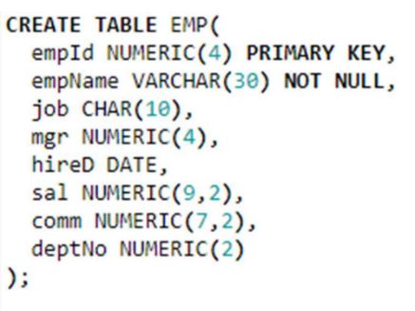

- Create a table DEPT.

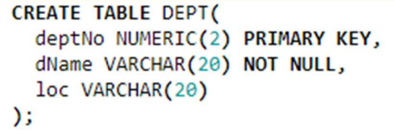

- Insert records into EMP table.

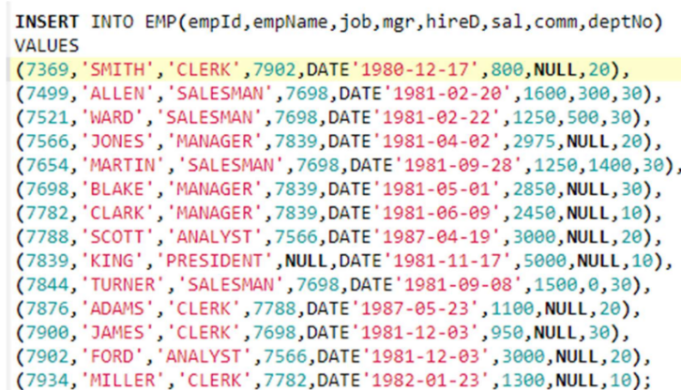

- Insert records into DEPT table.

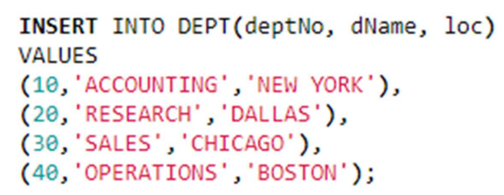

- Select all records from EMP table.

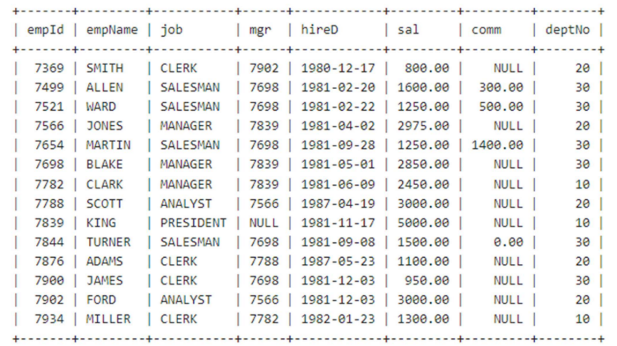

- Select all records from DEPT table.

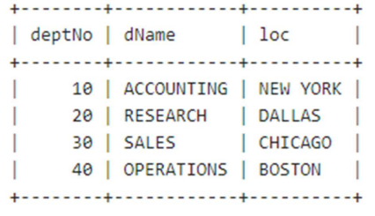

- Find the employee’s name, salary who is working in department number 20.

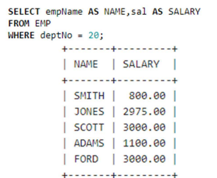

- Find employee’s name, job, salary of the employee who is ‘Manager’.

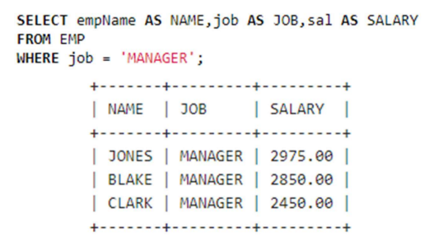

- Find employee’s name, job, salary of the employee who isn’t a ‘Manager’.

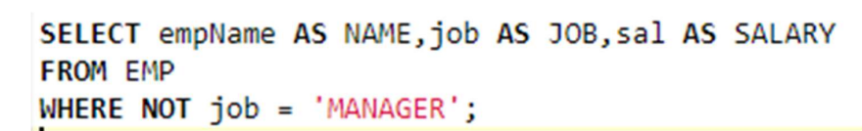
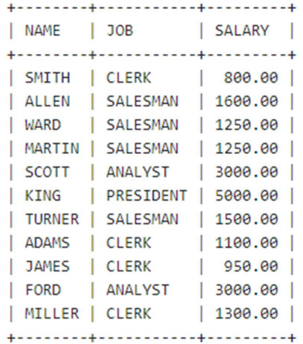

- Find employees who were hired between 1 MAR 1981 and 1 JUN 1983.

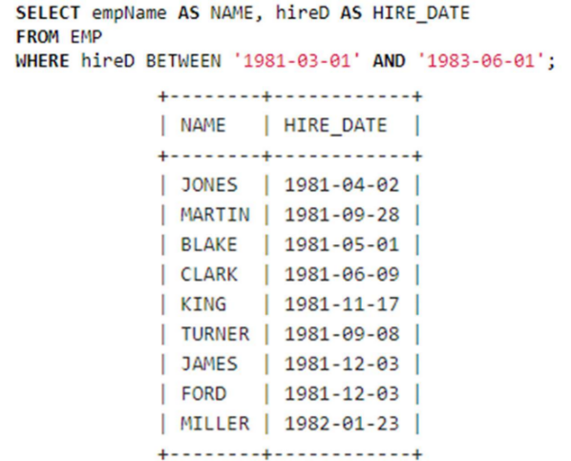

- Find Employees hired in 1981. 12. Find employees whose name starts with ‘S’.

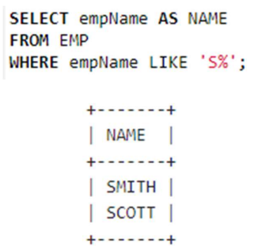

- Find employees whose name ends with ‘S’.

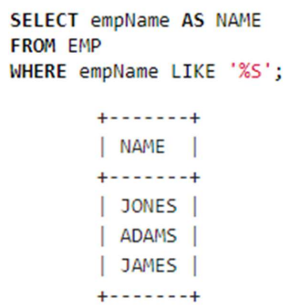

- Find employees working in Department Number 20 and 40.

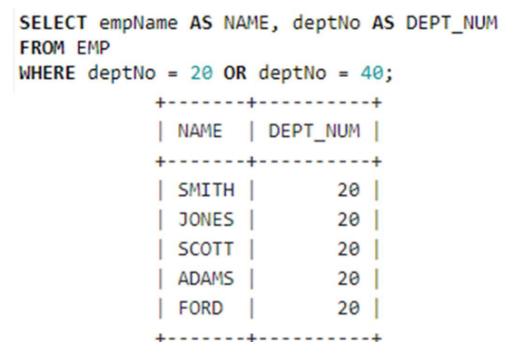

- Find employees who are Clerk and Salesman.

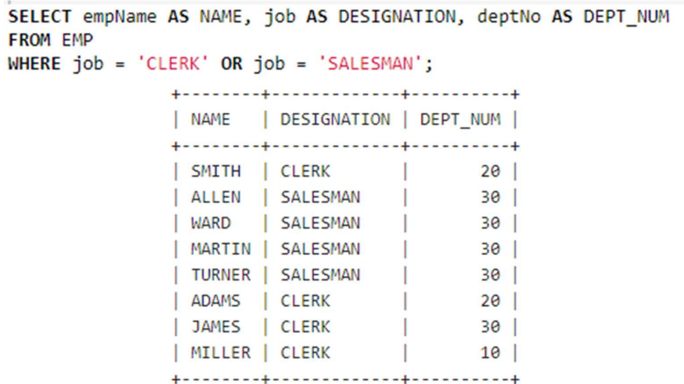

- Find employees who are Manager and having salary more than 2000.

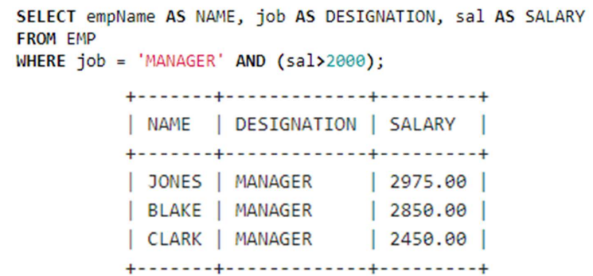

- Find employees who are working in Department Number 30 and order them by descending order.

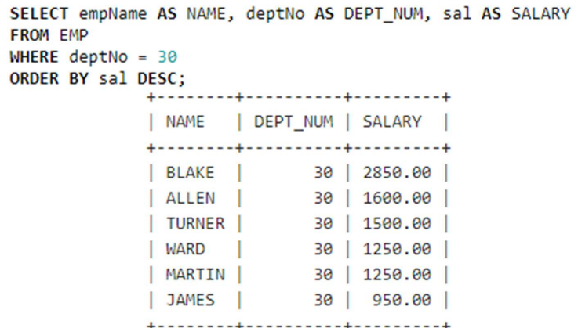

- Find Maximum and Minimum Salary from EMP table.

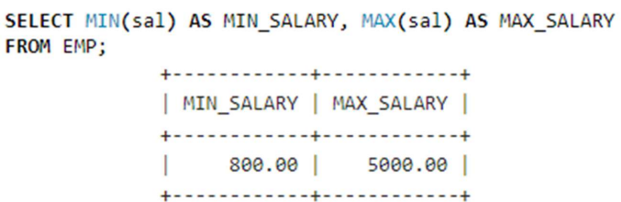

- Display Number of Employees per Department if count is greater than 3.

